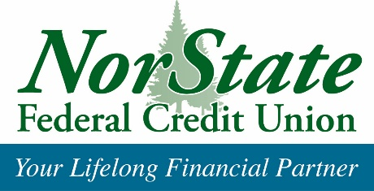
From the desk of:

Denise Duperré, CME

NorState Federal Credit Union, 78 Fox Street, Madawaska, Maine 04756

Direct Line: 207-316-1582 Toll Free: 1-800-804-7555 ext: 134

dduperre@norstatefcu.org

Press Release

February 24, 2020
FOR IMMEDIATE RELEASE

NorState FCU places 6th statewide in Ending Hunger Campaign 2019

NorState Federal Credit Union was recently presented an award for placing sixth statewide for raising funds for the Maine Ending Hunger Campaign.
Presenting the award at the February 20th Aroostook Chapter of Credit Union meeting was Maine’s Credit Union League President Todd Mason. Accepting on behalf of members, staff and volunteers was NorState Federal Credit Union’s CEO, Susan Whitehead.
“This recognition is very much appreciated as we have worked hard this year to come out so strong, ranking the highest in the County and placing 6th statewide is an amazing accomplishment and testimony to the credit union’s philosophy of People-Helping-People.
NorState members are some of the most generous and kind people who care about community and giving back, stated Whitehead.
Thank you to all who work all year long. To raise $28,031.24 dollar by dollar to bring forth food and monies to our local food pantries is beyond amazing.”
Denise Duperré, Executive Marketing Director of NorState FCU states, “Donors can take comfort in the fact that their donations remain local. Since 1999, NorState has raised over $330,000 in monies and 94,000 pounds of non-perishables.
The credit unions who belong to the Maine Credit Union League and participated in the Ending Hunger Campaign raised over $832,000 in 2019.
If you wish to donate toward local food pantries, send your check to NorState FCU, c/o Ending Hunger Campaign, 78 Fox Street, Madawaska, ME 04756 or drop off at your local NorState office. For more information about the Ending Hunger Campaign, call 1-800-804-7555 or visit us online at norstatefcu.org.
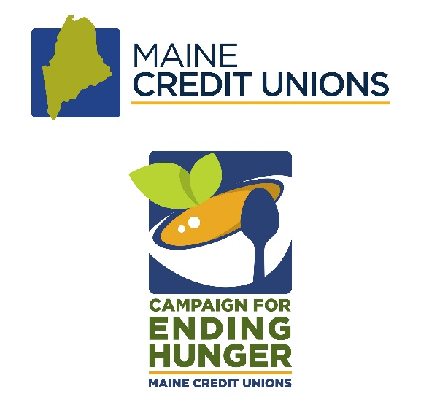

About Us: For the past 79 years, NorState FCU has served as a trusted financial partner by empowering members to achieve their goals. As a member-owned, community-focused, not-for-profit financial institution, NorState FCU offers a full-service list of financial products and convenience services and is ranked as a “Top 100” credit union in the U.S for 2019.
With more than $198 million in total assets, NorState FCU is a federally insured by the National Credit Union Association and serves over 14,000 members through 6 branches in Aroostook and northern Penobscot Counties in Maine, and nationwide with Co-op Network’s Shared Branching and surcharge free ATMs. For additional information about NorState FCU visit www.norstatefcu.org

